**CURRICULUM VITAE**

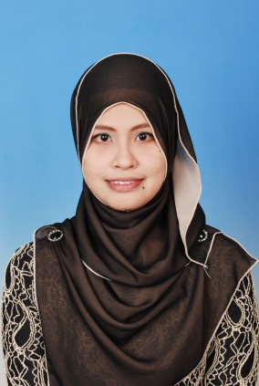

**PERSONAL DETAILS**

Name : Noor Alwani Binti Othman

Address : No 382 Lorong Yayasan 2, Taman Yayasan, 34600 Kamunting,

Perak Darul Ridzuan

Telephone No. : 017 – 5154370

Date Of Birth : 10 APRIL 1992

Place Of Birth : Hospital Daerah Taiping

Email Address : [nooralwani1992@gmail.com](mailto:nooralwani1992@gmail.com)

Marital Status : Single

**EDUCATIONS**

2010 – 2013 Politeknik Sultan Azlan Shah, Perak

2005 – 2009 Sekolah Menengah Kebangsaan Taman Panglima, Perak

**QUALIFICATIONS**

2013 Diploma in Accountancy

2009 Sijil Pelajaran Malaysia (SPM)

2007 Penilaian Rendah Malaysia (PMR)

**EXPERIENCES**

July – Dec 2012 Practical Training at SILVERSTONE BERHAD, Kamunting

Taiping, Perak

Dec 2009– Nov 2010 Work as Crew (Service and Cashier) at Taiping Sentral

McDonald’s

**EXTRACURRICULAR ACTIVITIES**

Nov – Dec 2013 Has attended and successfully completed as a Participating in the Polytechnic Graduate Employability Programme (Program Kebolehpasaran Graduan Politeknik) – High Value Workforce for Global Companies Programme (VALUES PROGRAMME – COHORT 2) at Polytechnic Mersing, Johor

2012 As a secretary in a program Jasa Bakti Siswa Siswi organized by the Diploma in Accountancy students located in Pertubuhan Kebajikan Ukhwah Anak Yatim Miskin, Sabak Bernam, Selangor

2011 Member of polytechnic Netball Team

- Represented Poloiteknik Sultan Azlan Shah in Netball Tournament on Majlis Sukan Perak

2009 Represented school in Netball Tournament

**OTHER SKILLS**

|  |
| --- |
| * Proficient in MS Office, Sage UBS and SAP system * Permanent Driving License (B2 and D) |
| * Able to work well both independent and energetic * Responsible, cheerful person and teamwork * Speak fluent in Bahasa Melayu and fairly well in English * Fluent in written Bahasa Melayu and fairly well in English * Recipient of Certificate LCCI in Prinsip Perakaunan of the Year 2009 * Recipient of Best Choir/ Choral Speaking Competition Award at English Commerce Department PSAS 2010 * Expected salary: RM1,700 and above   **REFERENCES**   * En Salehan Bin Marsim   Head of Commerce Department  Politeknik Sultan Azlan Shah  Behrang Stesyen 35950 Behrang  Perak Darul Ridzuan  012-2763028   * En. Zulkifli Bin Hj Ibrahim   Academic Advisor  Politeknik Sultan Azlan Shah  Behrang Stesyen 35950 Behrang  Perak Darul Ridzuan  013-6766764 |
|  |